
October 13, 2024
MADE BY: Stephen Li
ID: 19488679
Wintec

Forgot password change endpoint
TEST REPORT

Forgot Password Change Endpoint Specification

The final step of the “Forgot password”. Change password API call to add a new password. This will authenticate the user with his email and OTP before changing the password.
Accepted user type: student IRM client admin

Request
Method | URL
POST | api/forgotPassChange/

Type | Params | Values
POST | email | string
POST | otp | string
POST | server_ref | string
POST | password | string

Response
Status | Response
200 | {“description“:”Password changing successful. Please Sign In”}
400 | {"error":"server_ref,email or OTP is empty"}
404 | {"error":"Please provide valid email address"}
401 | {"error":"Email address did not match"}
404 | {"error":"Please provide password"}
403 | {"error":"Password must contain at least one uppercase letter, one lowercase letter, one number, one special character, and be at least 8 characters long."}
401 | {"error":"Invalid server_ref. Please try again"
401 | {"error":"Invalid OTP. Please try again"}
410 | {"error":"Invalid OTP. OTP has expired"}
500 | {"error":"Something went wrong. Please try again later"}

Process Flow
- Check user_verification table for matching active server_ref & OTP
  - [server_ref={server_ref} && otp={otp} and status=1]
  - Check the app_user_id and email
- If all records are matched →
  - Update status to 0 in user_verification table
  - Update the new password in application_user table
    - Create a password Hash with the strong hashing algorithm How to create a Password Hash
  - Return success response with 200 code
- If all records are not matched →
  - Update status to 0 in user_verification table [where server_ref={server_ref}]
  - Return 401 error code with response

All Bugs Identified in Postman

Bug 1: Test email is not that used to send “Forgot Password Request”
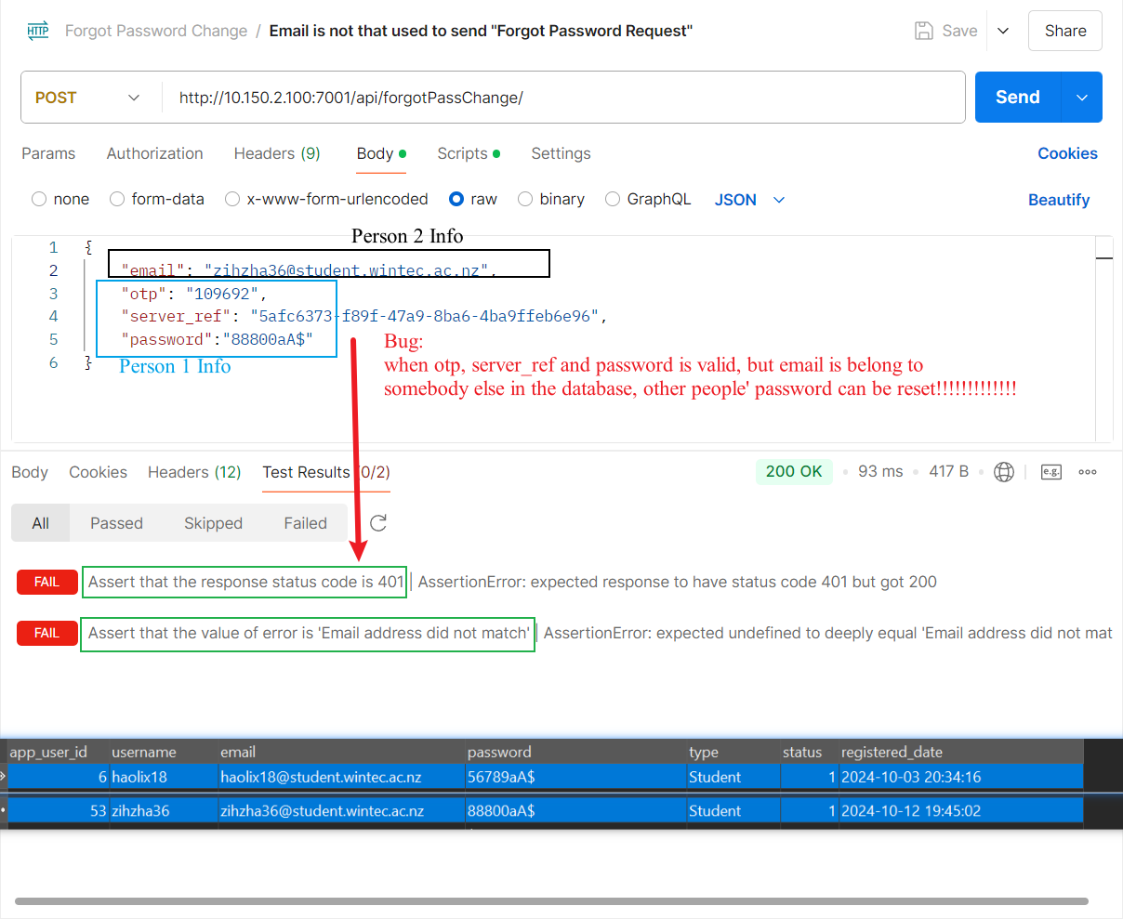

Bug 2: Test 6 numbers otp is incorrect
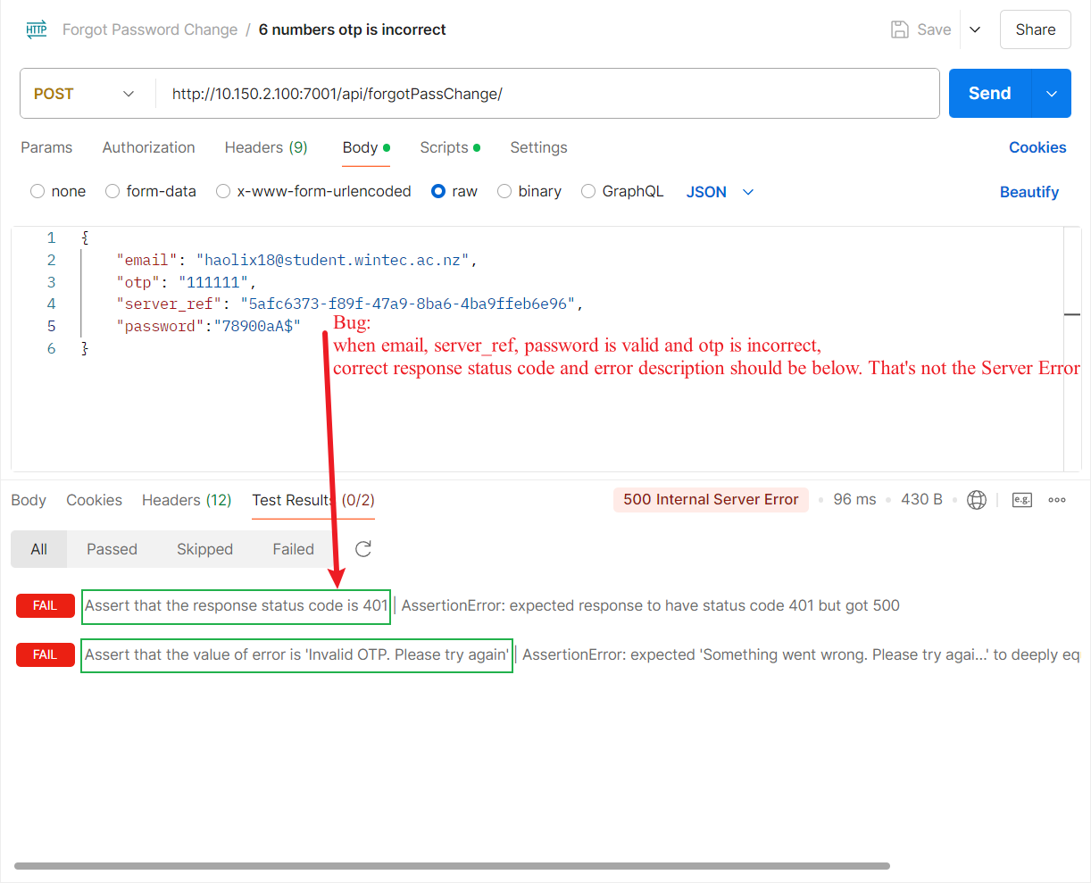

Bug 3: Test otp is empty
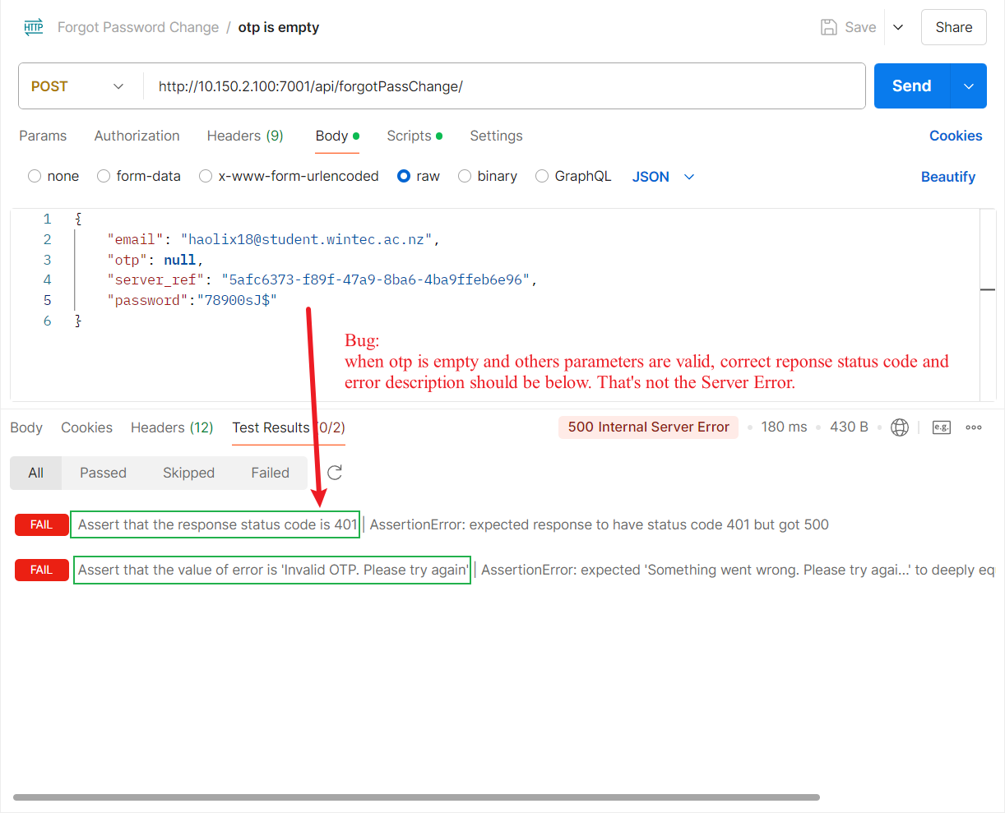

Bug 4: Test password is empty
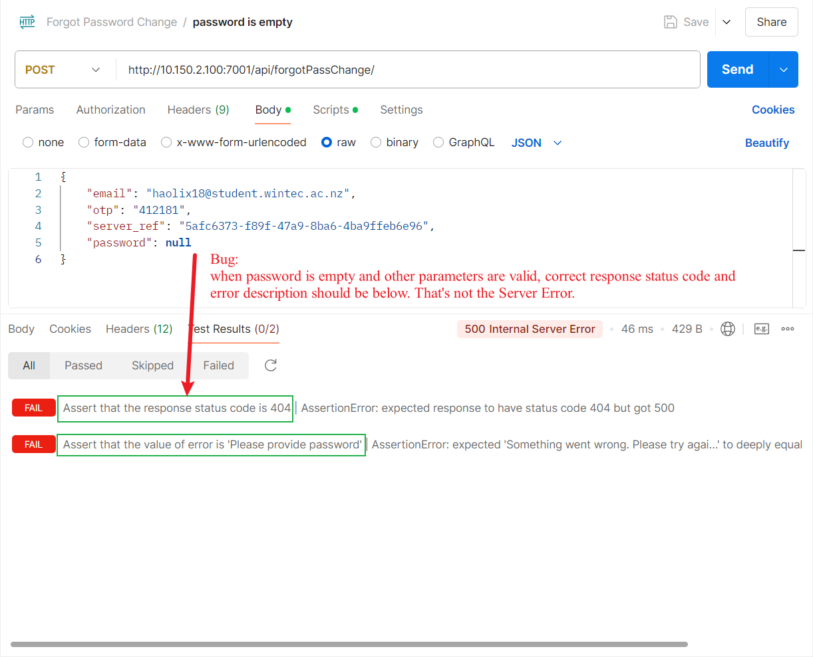

Bug 5: Test Email contain special character
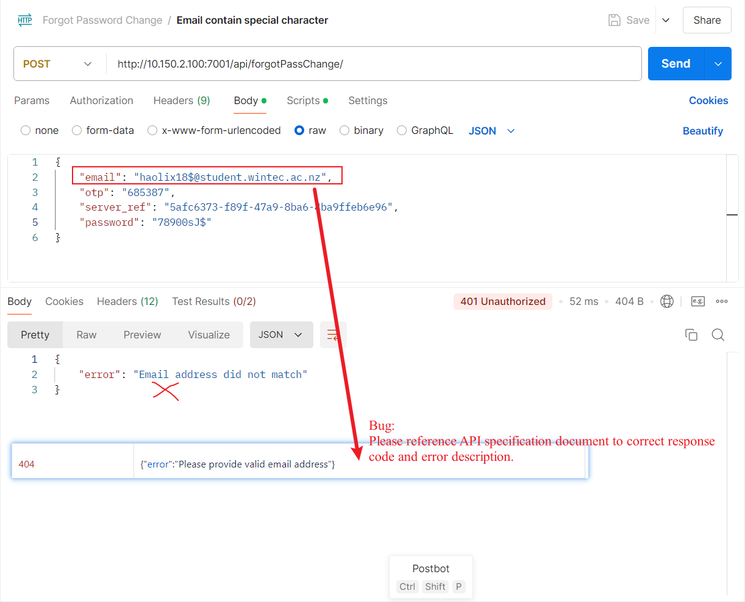

Bug 6: Test password does not include capital letters
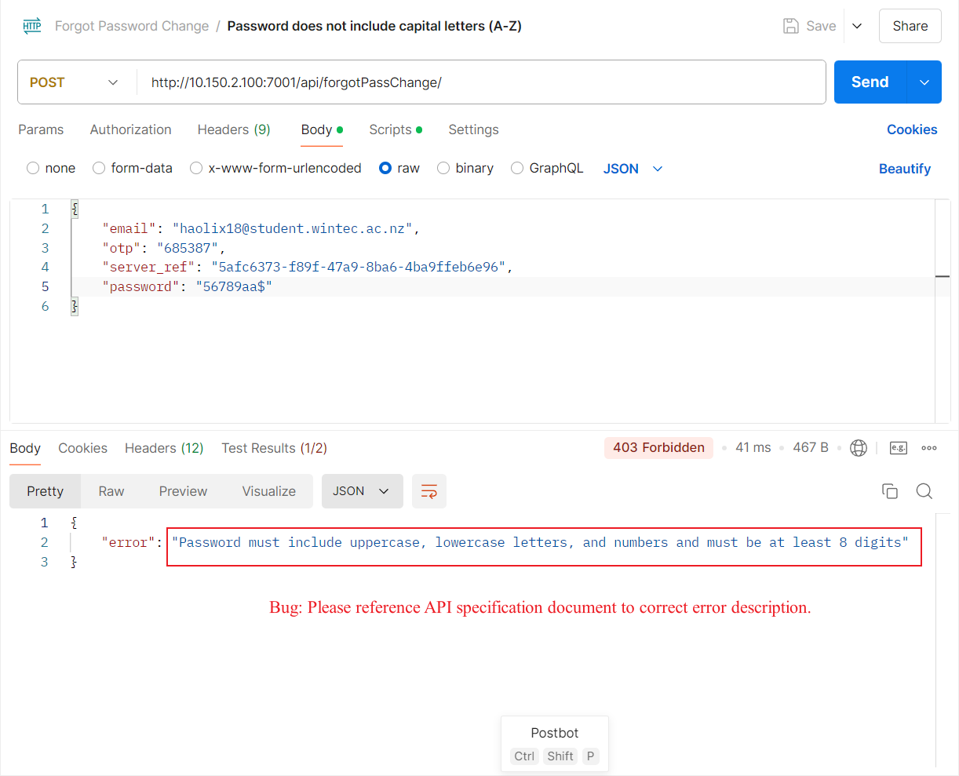

Bug 7: Test password does not include lowercase letters
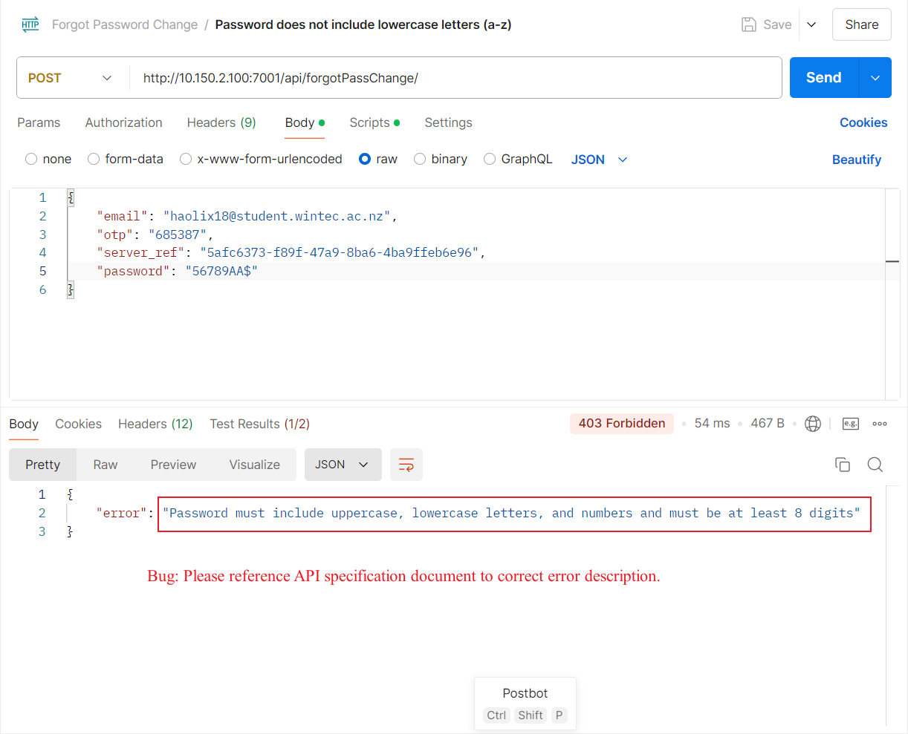

Bug 8: Test password does not include numbers
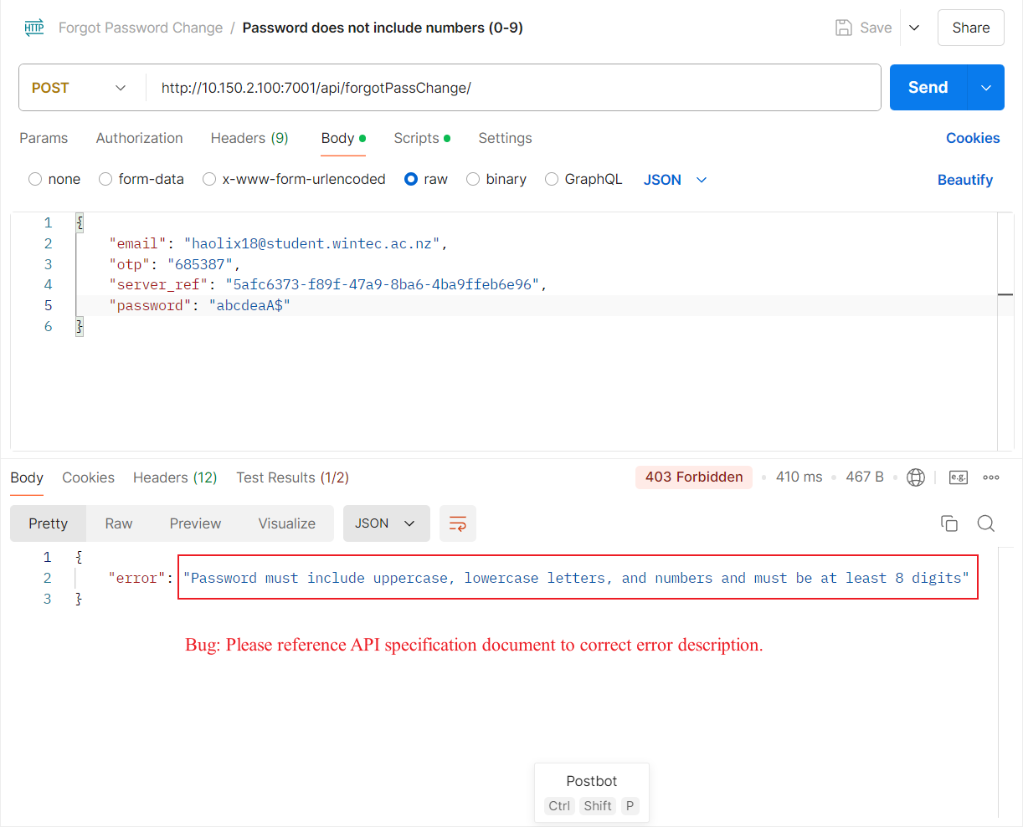

Bug 9: Test password does not include special characters
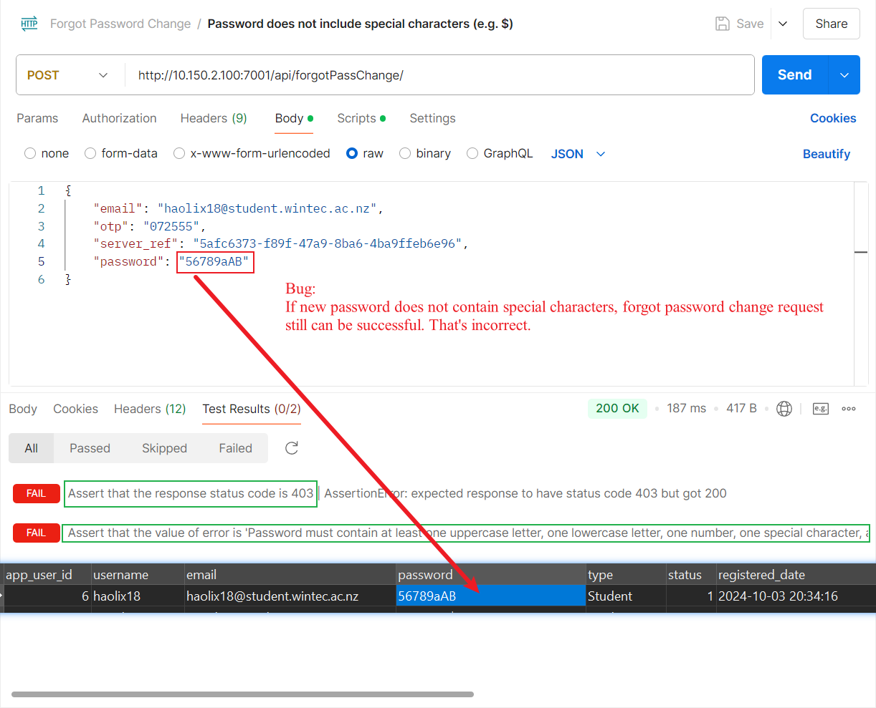

Bug 10: Test 7 characters password
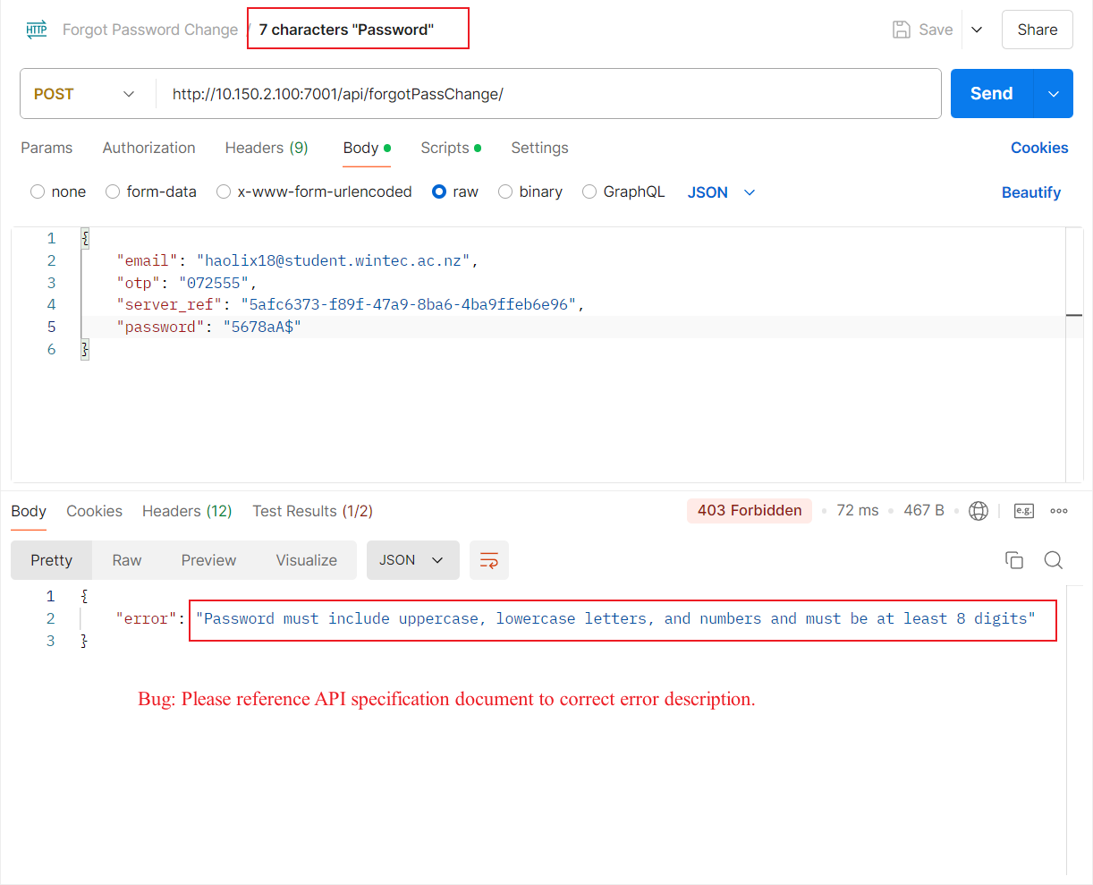

Bug 11: Test missing parameter
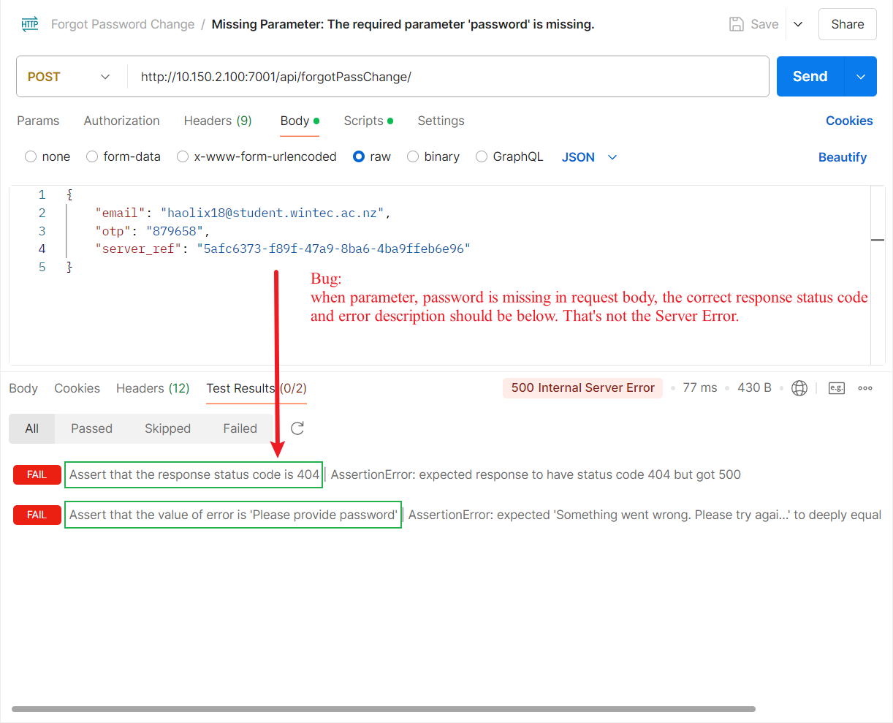

Bug 12: Test No parameter
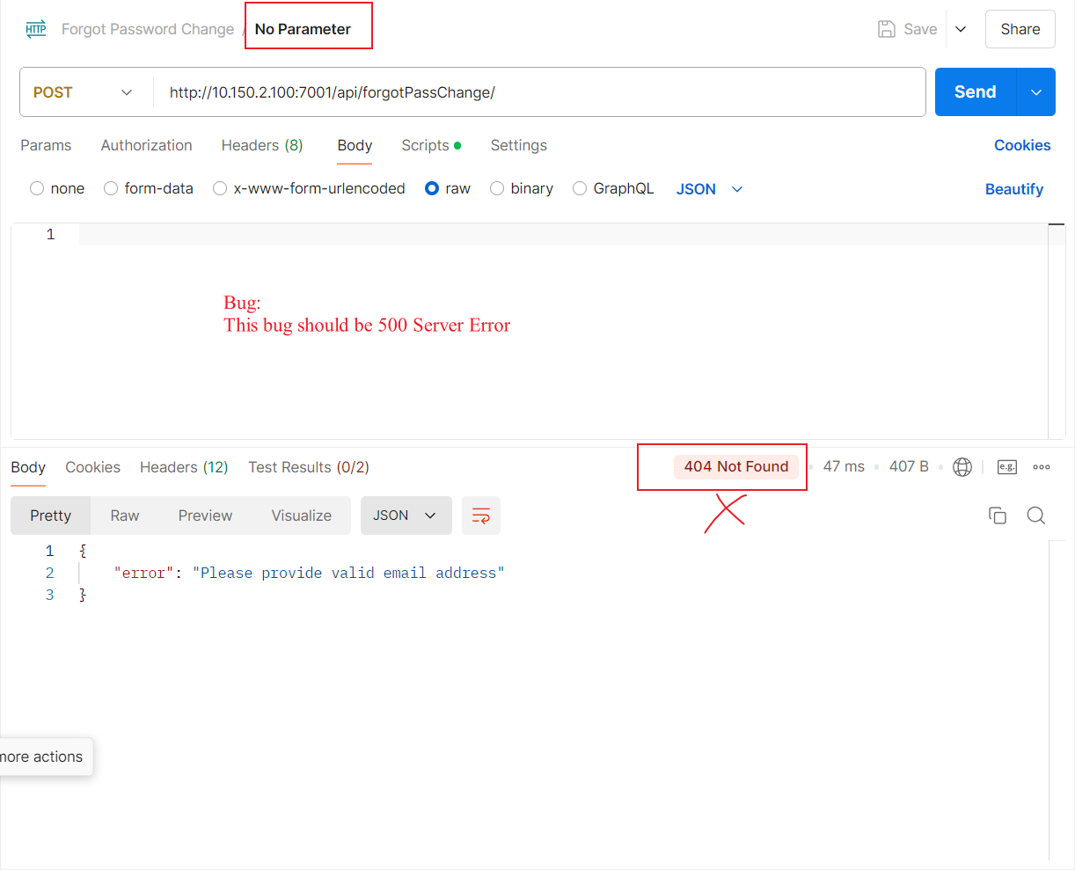

Bug 13: Test incorrect parameter name
